Lesson 13: Exponents
GETTING YOURSELF READY
Materials:  Mini whiteboards  Student Handout photocopies  Misconception to New Understanding Sheets |  |  | Your Preparation:  Put the Misconception to New Understanding Worksheet on a table for students to pick up on their way in to class. |  |  | Agenda with times:  Do Now and Purpose: 5 minutes  Key Vocabulary: 3 minutes  Building the Skill: 15 minutes  Structured Practice: 15 minutes  Guided Practice: 10 minutes  Closure: 2 minutes
GETTING YOUR STUDENTS READY
*Do Now:

Complete the Do Now Handout.
Objective: Today you will be able to understand how to solve expressions with exponents. |  |  |  | Proving Behavior: By solving word problems with exponents with 80% accuracy.
Purpose: We are doing this because you will need to simplify exponents to solve more complex problems such as finding a side length of a right triangle or evaluating expressions.
Key Vocabulary: (from Glencoe.com)
Create vocabulary cards with these definitions and a picture to represent them and hang on the word wall. Use the cards to ask the students the given questions about the vocabulary and have them respond chorally or on their mini-whiteboards.
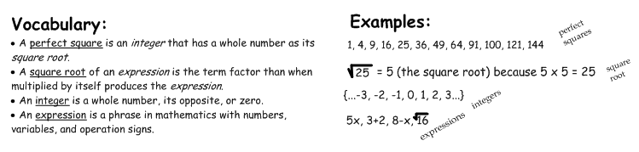
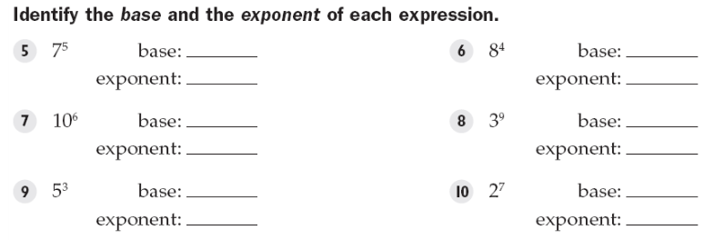
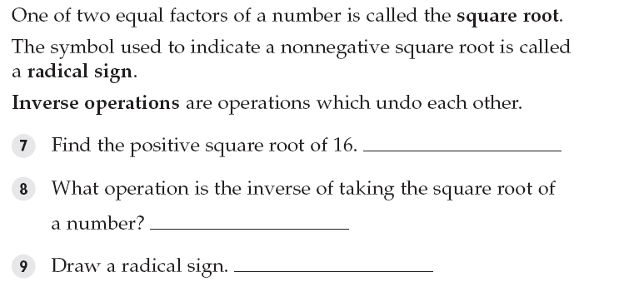
BUILDING THE SKILL
Exponents | Say/See: Chalk Talk: tell kids to come up to the Exponents poster to write and draw whatever they associate with exponents.  Do: Kids come to poster to write and draw stuff.  Say/See: Use Chalk Talk posters to teach vocabulary  Do: Kids fill in the blanks on worksheets  Say/See: Use Chalk Talk posters to teach the VIP: Simplifying with Exponents, one step at a time, pointing out the difference between the two examples. I will emphasize order of operations and how they play into this  Do: Have the students split their whiteboards into two columns. Have them write (-3)² in the first column and -3² in the second column. After each step you say/show on the VIP, have the students complete that step for each of their problems on their whiteboards and hold up their result.  Say/See: Think aloud problem 1.  Do: Have the students complete 2 and 3 as a whiteboard drill.  Say/See: Think aloud problem 4, asking aloud the question, “What repeats?” Since (-4) repeats, I have to include parentheses in my answer to show that BOTH the negative and the 4 repeat.  Do: Have the students complete 5-12 as a whiteboard drill.  Say/See: Think aloud the visual representation of squaring a number and complete problem 1 with the square.  Do: Have the students work with a partner to complete number 2 and then complete 3-15 on their own as a whiteboard drill.  Say/See: Have kids list as many perfect squares as possible in an allotted time (2 minutes).  Do: Kids list as many perfect squares on their papers.  If there’s time, play this game with everyone: http://www.softschools.com/math/games/exponents_practice.jsp  Comparing exponents
PRACTICING THE SKILL
*Structured Practice
Time: 5 minutes  Materials: Word Problems  Group Size: Pairs  Materials: Mini Whiteboards |  | There are three sets of word problems for the Structured/Guided Practice. Have the students complete the first problem of each section, one at a time, with a partner and hold up their whiteboards for you to see their answer. Because they are word problems, require the students to use their strategy of visualizing. They should draw some picture to represent the problem before solving. If the students are proficient, they may go on and use the remaining problems as their Guided Practice and work alone. If they need more help, you may do a whole class think aloud or give them another problem in the section to complete with a partner before releasing them to Guided Practice.
*Guided Practice (the proving behavior of the objective monitored by teacher)
Assignment: Guided Practice Handout. Have the students complete the remainder of the word problems. Make sure they show their visualization for each problem. |  |  |  |  | Criteria for Mastery: 80% of the remaining problems.
Explain Homework: Students may begin working on the Independent Practice, but it’s not due until the day after tomorrow.
*Closure: Write an exponent that estimates the number of jellybeans that can fit inside this classroom.
.

